Lebanese Arabic Phrasebook
By Hiba Najem

© 2014 Hiba Najem

Dedication
While living in Beirut, I have had the chance to meet a lot of foreigners who visit the country each for his/her own different reason. Many of them were struggling with the language, since the Fusha, which they had made a lot effort to learn, didn’t seem to help. (The modern standard Arabic or Fusha is a very decent and eloquent language that unites, and is the official language of, all the Arab countries.) The reason for that struggle is that every Arab country has its own dialect that differs from Fusha.
If your destination is Lebanon, than I recommend this book in order to feel free and confidant talking with the locals.
For the love of my country, which is sometimes very hard to love but at the same time very hard to leave, I dedicate my book to my language and to everyone who is willing to learn it.

Table of Contents
Preface
Introduction
Transliteration Guidelines
The Arabic Letters and Their Transliteration According To the Lebanese Dialect
The Chapters
Chapter 1: Basic Language
Numbers
Days
Colors
Pronouns
Prepositions
Chapter 2: Travelling
Airport
Directions
Money
Accommodation
Shopping
Chapter 3: Everyday Words and Sentences
Introductions
General
Greetings
Chapter 4: family, friends and relationships
Family
Friends
Love
Emotions
Chapter 5: Conjugation
To Have
To Go
To Eat
To Draw
To Want
Chapter 6: Miscellaneous
Random Words and Sentences
Chapter 7: Word Puzzles
Printable Puzzles
Conclusion

Preface
Some of you might have purchased this book because you already know me through my Lebanese Arabic teaching videos on Youtube. This book could be considered as an accompanying workbook for the Youtube channel “hiibanajem”, as well as an independent Lebanese Arabic phrasebook for new students. The channel consists of a number of videos in which I teach the Lebanese Arabic dialect. It has been around since January 2011, and at the time of writing this book, there are around 50 videos available for everyone to watch.
The purpose of this book is not only to organize all the material taught on the channel throughout the many lessons and to provide a written reference for the students who already have watched the videos, but also to offer new students a more structured access to the material where they could learn the dialect and use the videos as additional guides to deepen their understanding. The last section of this book will consist of language puzzles such as crosswords, word search and fill-in-the-blanks that will help you master the material.

Introduction
The method of teaching is vaguely inspired by the Rosetta Stone method that teaches the dialect through using practical sentences instead of memorizing strict grammatical rules.
All the words and phrases are transcribed from the videos, so there will be a link next to each sentence referring you to the relevant video. You will be able to hear the correct pronunciation in order to master your accent and find detailed explanations of each word in complicated phrases.
The sentences will be divided into themes like “Introductions” or “Travelling” and they will be written in 3 forms:
1. In English first.
2. Then in Lebanese transliteration (Latin alphabet) for people who can’t read Arabic.
3. And eventually in Lebanese (Arabic alphabet) for those who are Arabic literate.
Note: Unfortunately, since Kindle does not support Arabic text at the moment, the sentences written using the Arabic alphabet had to be inserted as images and not as text. Therefore these sentences on some versions of Kindle, namely the Kindle Paperwhite or Kindle DX, might appear as very large relative to the normal font size, but that could easily be solved by adjusting the font size accordingly. (It might be best to change the font size until these two “A”s appear approximately close in size: A
I would also recommend rotating the screen to the “landscape view” for easier reading, but that is optional and up to each reader’s preferences.

Transliteration Guidelines
Since the Arabic alphabet is quite different from the Latin one that does not include the same letters, we’ll have to agree upon certain rules that we’ll use throughout the book as to avoid any confusion. The representations chosen will be based on their simplicity in contrast with the academic but more complex symbols such as [ʔ] or (ħ). There will be a table presenting each letter and its transliterated representation, preceded by an explanation of some of the letters used. While the table might only be useful for Arabic readers, the explanation will help all readers to recognize the sounds of the transliteration. If any of the following information seems too complicated for you, don’t worry, you will find it to be simpler as you go along and read the actual words and phrases. These are just guidelines you can refer to if you find any difficulty in reading transliterations:
- 1. The Hamza (ء) which is a glottal stop, is not a full letter and is not one of the 28 letters of the alphabet but it is widely used in the language and especially in the Lebanese dialect, as in most Lebanese areas, the Qaf (ق) (pronounced as a “K” or a “Q” in standard Arabic) is pronounced as a Hamza and labeled as a glottal stop. The Hamza is phonetically represented as /ʔ/ while academically represented as a “modifier letter right half ring” (ʾ) which will be replaced by an apostrophe in this book (‘). You might find it to be represented with the number (2) on the web, as this is the conventional chatting representation of it, inspired by the inverted similarity in shape of the (2) and the (ء).

2. The Aleph (ا), the first letter of the Arabic alphabet, takes many forms, depending on its accentuation and on the placement of the Hamza in relation to it, facts that change the way it sounds. It might sound as a glottal stop or as a long vowel. For this reason, in cases where it sounds as a glottal stop it will be transliterated as a simple Hamza (‘) and in cases where it sounds like a vowel, it will be represented with the respective vowels (a), (e), (i), (o), or (ei). The latter, (ei), is used as the sound of the accentuated letter (é).

- 3. Thaa’ (ث), is an Arabic letter that sounds like (th) in English words like (th)ink or ba(th), but in the Lebanese dialect it is most commonly replaced by either a (t) or an (s) sound. So it might be written in words as a (ث), but pronounced as is written in the Transliteration. (Ex: Snow=Talej= ثلج)

4. The Arabic letter (ع) or Ayn has no similar letters or sounds in the Latin alphabet. It is articulated with the back of the throat and the root of the tongue. It is phonetically represented as /ʕ/, while its academic representation is the “modifier letter left half ring” (ʿ) which is similar to the representation of the Hamza. In order to avoid any confusion between the Hamza and the Ayn, the latter will be represented as it is in chatting forums with the number (3) because of its mirrored resemblance to (ع) “3ayn”.

5. Ghayn (غ) is a variant of 3ayn (ع) in shape but is different in sound. The closest popular equivalent to its sound is the Parisian French (r). It is phonetically represented as /ɣ/ but most commonly transliterated as (gh) which we will use throughout the book.

- 6. The Haa’ (ح) which is similar to the 3ayn in articulation (with the back of the throat and the root of the tongue) but different in phonation is represented phonetically as /ħ/ and academically as (ḥ) while in this book it will be represented as a capital (H) which is usually the simplest symbol of the Haa’. You might find that it is sometimes written as a (7) because of the number’s resemblance to the upper part of (ح).

7. The Khaa’ (خ) is pronounced in a way that is very similar to German, Scottish, and Polish (ch), Russian (х), and Spanish (j). It is phonetically represented as /x/, while its most common transliteration is (kh) which is used almost everywhere and is therefore used in this book. You might also find it to be represented as (5) which also resembles a distorted mirrored (خ) missing the dot.

8. Thaal (ذ) and Thahh (ظ) which are variant of each other, and resemble the sound of the English (th) in (th)is or fea(th)er, is most commonly replaced by either a (d) or a (z). Ex: Memory=Zeikra= ذاكرة)
9. Finally, some words end with the sound (é), or might have this sound in the middle of the word. These will be transliterated as (eh) in the end, and (ei) in the middle.

As for the Lebanese words written in the Arabic alphabet, words ending with the (a) sound in Lebanese will be written:
- as (ا) whenever the same word in Modern Standard Arabic end with (ءا) or (مَا) like ءحَمرا or عَندها, written as حَمرا or عَندا
- as (ة) whenever the word is feminine and has a masculine version, like رايحة
- otherwise, they will be seen as (ه)

The Arabic Letters and Their Transliteration According To the Lebanese Dialect
ا | a|i|o|e|ei
ب | b
ت | t
ث | t|s
ج | j
ح | H
خ | kh
د | d
ذ | d|z
ر | r
ز | z
س | s
ش | sh
ص | s
ض | d
ط | t
ظ | d|z
ع | 3
غ | gh
ف | f
ق | ‘
ك | k
ل | l
م | m
ن | n
ه | h
و | w|ou
ي | i|y

The Chapters
There are seven chapters in this book. The first six define categories of the phrases taught throughout the chapters, while the last one is dedicated for language exercises and puzzles.
The first chapter entitled “Basic Language” contains five subcategories: Numbers, Colors, Days, Pronouns and Prepositions.
The second chapter, “Travelling”, offers sentences that you will need if you are travelling to Lebanon and the subcategories are arranged by what you might chronologically use: Airport, Directions, Money, Accommodation and Shopping.
The third, fourth and fifth chapters will contain everyday sentences as well as phrases to use around friends, family and in relationships and conjugations of a few verbs that might be useful. They will also shed light on how conjugation works in the Lebanese Arabic dialect.
The sixth is the last chapter containing phrases. It will have a variation of random sentences, uncategorized, which I have been asked to teach by viewers of the videos or which I have found to be practical and fun to be learnt.
The final chapter, as mentioned above, will consist of “fill in the blank” exercises, as well as crosswords and word search puzzles. If you find the printing of the exercises is complicated to do directly off of your Kindle device, please sign up here for a PDF version of the puzzles and their solutions: http://bit.ly/ExercisesPDF

Chapter 1: Basic Language

Numbers
Zero | صِفر  sefer  Video Lesson 4
One | واحد  waHad  Video Lesson 4
Two | تنَين  tnein  Video Lesson 4
Three | تلاتِه  tleiteh  Video Lesson 4
Four | أربعَه  arb3a  Video Lesson 4
Five | خمسه  khamseh  Video Lesson 4
Six | سِتّه  setteh  Video Lesson 4
Seven | سَبعَه  sab3a  Video Lesson 4
Eight | تمانه  tmeineh  Video Lesson 4
Nine | تسعه  tes3a  Video Lesson 4
Ten | عشره  3ashra  Video Lesson 4

Days
Monday | تَنين  tanein  Video Lesson 14
Tuesday | تَلاتَه  taleita  Video Lesson 14
Wednsday | أُربعا  orb3a  Video Lesson 14
Thursday | خَميس  khamees  Video Lesson 14
Friday | جمعه  jem3a  Video Lesson 14
Saturday | سَبت  sabet  Video Lesson 14
Sunday | أَحَد  aHad  Video Lesson 14
Today | اليَوم  lyom  Video Lesson 7
Today is Monday | اليوَم التَنَين  lyom el tanein  Video Lesson 7
Morning | صُبح  sobeH  Video Lesson 7
Noon | ضُهر  doher  Video Lesson 7
Night | لَيل  leil  Video Lesson 7
Moon | أَمَر  amar  Video Lesson 19
Sun | شَمس  shames  Video Lesson 21
Autumn | خَريف  khareef  Video Lesson 7
Winter | شِتي  sheteh  Video Lesson 7
Spring | رَبيع  rabee3  Video Lesson 7
Summer | صَيف|صَيفيه  sayf | sayfiyeh  Video Lesson 23
We are now in the spring | نِحنا هَلَء بِفَصل الخَريف  neHna halla' b fasl el rabee3  Video Lesson 7
It’s sunny but it’s not very hot | في شَمس ومِش كتير شوب  fi shames w mesh kteer shob  Video Lesson 7
In the summer we go to the beach | بالصَيف مِن روح عَلى البَحر  bl seif mn rouH 3al baHer  Video Lesson 7
The sun is setting | الشَمس عَم بتغيب  el shames 3am betgheeb  Video Lesson 7

Colors
Red | حَمرا/ أَحمَر  Hamra/aHmar  Video Lesson 22
Green | خَضرا/ أَخضَر  khadra/akhdar  Video Lesson 22
Blue | زَرقا/ أَزرق  zar'a/azra'  Video Lesson 22
Yellow | صَفرا/ أَصفَر  safra/asfar  Video Lesson 22
Black | سَودا/ أَسوَد  sawda/aswad  Video Lesson 22
White | بَيضا/ أَبيَض  bayda/abyad  Video Lesson 22
Grey | رمَادي  rmeideh  Video Lesson 22
Purple | بَنَفسَجي  banafsajeh  Video Lesson 22
Pink | زَهري  zahreh  Video Lesson 22
Brown | بِنِّي  benneh  Video Lesson 22
Red balloon | بَالون أَحمَر  balon aHmar  Video Lesson 'Valentine'
Red flower | وردِه حَمرا  wardeh Hamra  Video Lesson 'Valentine'

Pronouns
I | أنا  ana  Video Lesson 13
You | إنتِ/إنتَ  enteh/enta  Video Lesson 13
He | هوّي  howeh  Video Lesson 13
She | هيّي  hiyeh  Video Lesson 13
We | نِحنا  neHna  Video Lesson 13
You (plural) | إنتو  ento  Video Lesson 13
They | هنّي  henneh  Video Lesson 13

Prepositions
And | وَ  wa  Video Lesson 10
So | فَ  fa  Video Lesson 10
But | بَس  bas  Video Lesson 10
To (location) | عَلى  3ala  Video Lesson 10
To (cause) | تَ  ta  Video Lesson 10
After | بعدين  ba3dein  Video Lesson 10
When | لمَّا  lamma  Video Lesson 10
From | مِن  men  Video Lesson 10
On | عَلى  3ala  Video Lesson 10
About | عَن  3an  Video Lesson 10
That | إنّو  enno  Video Lesson 10
Because | لأنّو  la'enno  Video Lesson 10
So finally we agreed on the red color | فَأخيرا" إتفأنا على اللَّون الأحمَر  fa akheeran ttafa'na 3ala el lon el aHmar  Video Lesson 10
I would like to come but I'm traveling | عَبالي إجي، بَس مسافرة/مسافَر  3abeileh ejeh, bas msefra/msefar  Video Lesson 10
She's going to the gym | هِيّي رايحة عَلى النادي  hiyeh rayHa 3al neideh  Video Lesson 10
Eat the sandwich then the chocolate | كول العروس بعدين الشوكولا  kol el 3arous ba3dein el chocola  Video Lesson 10
I will call you when I get back | بحكيك لمَّا إرجَع  beHkeek lamma erja3  Video Lesson 10
I buy milk from the supermarket | أنا بشتري حَليب مِن السوبرماركت  ana beshtereh Halib men el supermarket  Video Lesson 10
My book is on the table | كتابي عَلى الطاوله  kteibeh 3ala el tawleh  Video Lesson 10
I'm talking about last night | عَم بحكي عَن مبارِح  3am beHke 3an mberiH  Video Lesson 10
He said that he will come | هوّي آل إنّو جايي  howe 'aal enno jeyeh  Video Lesson 10
He said that she's coming | هوّي آل إنّا جايي  howeh 'aal enna jeyeh  Video Lesson 10
I am here because I lost my baggage | أنا هون لأنّو ضَيَّعت غراضي|شِنطي  ana hon la'enno dayya3et ghradeh|shenateh  Video Lesson 10

Chapter 2: Travelling

Airport
Welcome to Lebanon | أهلا و سَهلا بِلبنان  ahla w sahla b lebnein  Video Lesson 2
Excuse me my baggage is late | عَفوا"، شِنَطي|غراضي تأخَرِت  3afwan, shenateh|ghradeh t'akharit  Video Lesson 2
Excuse me I lost my baggage | عَفوا"، ضَيعت شِنَطي|غراضي  3afwan, dayya3et shenateh|ghradeh  Video Lesson 2
Excuse me I want to exchange money | عَفوا"، بَدِّي صَرِّف مَصَاري  3afwan, baddeh sarrif masareh  Video Lesson 2
Hello I want to go to Ashrafieh | مَرحَبا، بَدِّي روح عَلى الأشرَفيّه  marHaba, baddeh rouH 3al Ashrafieh  Video Lesson 2

Directions

Where am I? | أنا وَين؟  ana wein?  Video Lesson 5
Left | شمال  shmeil  Video Lesson 5
Right | يمين  yameen  Video Lesson 5
Straight | دِغري  deghreh  Video Lesson 5
Road | طريء  taree'  Video Lesson 5
Square | ساحَه  seiHa  Video Lesson 5
How to go to Hamra | كيف بروح عَلى الحمرا؟  kif brouH 3al Hamra?  Video Lesson 5
What’s the name of the street | شو إسم الشَارِع؟  shou esem el sheiri3?  Video Lesson 5
Which bus should I take? | أيّا باص باخد؟  ayya bus beikhoud?  Video Lesson 5
Does the bus pass by here | بيأطع الباص مِن هون؟  byo'ta3 el bus mn hon?  Video Lesson 3.2
Is there a restaurant nearby? | في مَطعَم أريب مِن هون؟  fi mat3am areeb mn hon?  Video Lesson 5
Last question, is there a map | آخِر سوآل، في خريطه؟  ekhir sou'aal, fi khareeta?  Video Lesson 3.2

Money
250 | ميتَين و خَمسين  meetein w khamseen  Video Lesson 4
500 | خَمس مِيِّه  khams miyyeh  Video Lesson 4
1000 | أَلف  alf  Video Lesson 4
5000 | خمس-ة-آلاف  khams-t-aleif  Video Lesson 4
10000 | عشر-ة-آلاف  3asher-t-aleif  Video Lesson 4
20000 | عِشرين ألف  3eshreen alf  Video Lesson 4
50000 | خَمسين ألف  khamseen alf  Video Lesson 4
100000 | مِيّة-ألف  meet alf  Video Lesson 4

Accommodation
Hello I want to reserve a room | مَرحبا بَدِّي إحجُز أوضه  marHaba baddeh eHjouz ouda  Video Lesson 3.1
I’m looking for a small room with one bed | أنا عَم فَتِّش على أوضة صغيرة مَع تَخت  واحَد  ana 3am fattish 3ala ouda zgheereh ma3 takhet waHad  Video Lesson 8
I want it for one week | بَدّي يَاها لجِمعه  baddeh yeha la jem3a  Video Lesson 3.1
How much should I pay | أدّاي لازِم إدفَع؟  addeh lezim edfa3?  Video Lesson 3.1
I want the cheapest room | بَدِّي أرخَص أوضه  baddeh arkhas ouda  Video Lesson 3.1
What time is breakfast served | أيّا ساعه الترويقه؟  ayya se3a el terwee'a?  Video Lesson 3.1
Home | بَيت  beit  Video Lesson 8
Apartment | شِأّه  she'a  Video Lesson 8
An apartment for rent | شِأّه للأجار  she'a lal ajar  Video Lesson 8
I’m looking for an apartment to rent | عَم فتِّش على شِأّه للأجار  ana 3am fattish 3ala she'a lal ajar  Video Lesson 8
Where can I find an apartment to rent | وين فيني لاقي شأّه للأجار؟  wein feeneh lei'eh she'a lal ajaar?  Video Lesson 8
How much should I pay per month | أدّاي لازِم إدفَع بالشهر؟  addeh lezim edfa3 bel shaher?  Video Lesson 8
Are the electricity and water bills included? | الكهرَبا والمَي ضُمن الأَجار؟  el kahraba wel may domn el ajaar?  Video Lesson 8
Is the bathroom common? | الحَمام مُشتَرَك؟  el Hemmeim moushtarak?  Video Lesson 8

Shopping
Shirt | أميص  ameess  Video Lesson 11
High heels | سكربينِه  scarbeeneh  Video Lesson 11
Shoe | صُبَّاط  sobbat  Video Lesson 11
Dress | فُستان  fostan  Video Lesson 11
Glasses | عوينات  3wayneit  Video Lesson 11
How much does it cost | أدّاي حأّا/حأّو؟  addeh Ha'a/Ha'o?  Video Lesson 11
How much do you want | أدّاي بِتريد؟  addeh betreed?  Video Lesson 2
Is there another size | في غَير إياس؟  fee gheir 'yeiss?  Video Lesson 11
I need a smaller one | بدّي إياس أَصغَر  baddeh 'yeiss asghar  Video Lesson 11
I need a larger one | بدّي إياس أَكبَر  baddeh 'yeiss akbar  Video Lesson 11
In how many colors does it come | كَم لون في مِنّا؟  kam lon fi menna?  Video Lesson 11
Does it look good on me | حِلوة/ حِلو علَيّ؟  Helweh/Helo 3layyeh?  Video Lesson 11
Are the items on sale | في "سايل"/عاملين "سايل"؟  fee sale? | 3amleen sale?  Video Lesson 11
Can I get it for a better price? | فيكي ترَخصيلي/فيك ترَخصلي؟ فيكي تَعمليلي سِعر/فيك تَعمِلّي سِعر؟  feekeh trakhseeleh/feek trakhessleh? | feekeh ta3mleeleh/feek ta3melleh se3er?  Video Lesson 11

Chapter 3: Everyday Words and Sentences

Introductions
Hello how are you | مَرحبا كيفِك/كيفَك/ كيفكُن؟  marHaba keefik/keefak/keefkoun?  Video Lesson 1
Good morning | صَباح الخير|صَباح النور  sabaH el kheir|sabaH el nour  Video Lesson 9
Good evening | مَسا الخَير|مَسا النور  masa el kheir|masa el nour  Video Lesson 9
How are you? | كيفِك/كيفَك/كيفكن  keefik/keefak/keefkoun?  Video Lesson 9
What's your name | شو إسمِك؟ إسمَك؟  shou esmik/esmak?  Video Lesson 15
What do you work | شو بتشتغلي/بتشتغل/بتشتغلوا؟  shou bteshteghleh/bteshteghil/bteshteghlo?  Video Lesson 15
I work as a translator | بِشتغل تِرجمان  beshteghil terjmein  Video Lesson 1
My name is Maria I come from Mexico to study Arabic | إسمي ماريا، جايي من المكسيك إدرُس عَربي  esmeh Maria, jeyeh mnel mexeec edrous 3arabeh  Video Lesson 1
What do you study | شو بتدرسي/بتدرُس/بتدرسوا؟  shou btedrseh/btedrous/btedrso?  Video Lesson 15
What did you study | شو دَرستي/دَرَست/درستوا؟  shou darasteh/daraset/darasto?  Video Lesson 15
Where are you from | مِن وَين إنتِ/ إنتَ؟  min wein enteh/enta?  Video Lesson 15
Where do you live | وَين آعدي/آعِد/آعدين |ساكني/ساكِن/ساكنين |عايشي/عايِش/عايشين؟  wein 'ei3deh/'ei3id/ei3deen | seikneh/seikin/seikneen | 3aaysheh/3aayish/3aaysheen ?  Video Lesson 15
What do you do after work | شو بتَعملي/بتَعمِل/بتعملوا بعد شغلِك/شغلَك/شغلكن؟  shou bta3mleh/bta3mil/bta3mlo ba3ed sheghlik/sheghlak/sheghelkoun?  Video Lesson 15
Do you do sports | بتَعملي/بتَعمُل/بتعملوا رياضة؟  bta3mleh/bta3mil/bta3mlo sport?  Video Lesson 15
What's your phone number | شو رأمِك/رأمك/أرآمكن؟  shou ra'mik/ra'mak/ar'aamkoun?  Video Lesson 15
I'll call you maybe we'll go out someday | رَح إحكيكي/ إحكيك بَركي منَعمُل شي،شي نهار  raH eHkikeh/eHkik barke mna3mil shi, shi nhar  Video Lesson 15
What’s new | شو في جديد؟  shou fi jdeed?  Video Lesson 9
It was nice seeing you | مبَسَطِت شفتِك/شفتَك/ شِفتكُن  mbasatet sheftik/sheftak/sheftkoun  Video Lesson 9

General
What do you want? | شو بدِّك/ بدَّك/ بدكُن  shou baddik/baddak/baddkoun?  Video Lesson 6
Do you want something? | بدِّك/بدَّك/بدكُن شي؟  baddik/baddak/badkoun shi?  Video Lesson 6
Can you help me | فيكي تساعديني؟/فيك تساعدني؟/فيكُن تساعدوني؟  feekeh tse3deeneh/feek tse3edneh/feekoun tse3douneh?  Video Lesson 11
What happened? | شو صار؟  shou sar?  Video Lesson 9
What’s happening? | شو عم بصير؟ شو في؟  shou 3am b seer? Shou fi?  Video Lesson 9
How was your day? | كيف كان نهارِك/ نهارَك/نهاركُن؟  keef kein nharik/nharak/nharkoun?  Video Lesson 9
What are you doing tomorrow | شو عاملي/ عامِل/عاملين بُكرا؟  shou 3aamleh/3aamil/3aamleen bukra?  Video Lesson 9
I will see you soon | بشوفِك/بشوفَك/بشوفكن أريباً  bshoufik/bshoufak/bshoufkoun areeban  Video Lesson 9
I will call you | بحكيكي/ بحكيك/ بحكيكُن  beHkeekeh/beHkeek/beHkeekoun  Video Lesson 9
My friend and Iare studying | أنا ورفيئتي/ رفيئي عم نِدرُس  ana w rfee'teh/rfee'eh 3am nedrous  Video Lesson 10

Greetings
Merry Christmas | ميلاد مَجيد  mileid majeed  Video Lesson 17
Happy new year | عام سَعيد  3aam sa3eed  Video Lesson 17

Chapter 4: family, friends and relationships

Family
Family | عَيله  3ayleh  Video Lesson 12
Father | بيِّي  bayyeh  Video Lesson 12
Mother | إمِّي  emmeh  Video Lesson 12
Brother | خيِّي  khayyeh  Video Lesson 12
Sister | إختي  ekhteh  Video Lesson 12
Grand-mother | سِتِّي  setteh  Video Lesson 12
Grand-father | جِدّي  jeddeh  Video Lesson 12
Aunt (paternal) | عَمتي  3ammteh  Video Lesson 12
Aunt (maternal) | خَالتي  khalteh  Video Lesson 12
Uncle (paternal) | عَمّي  3ammeh  Video Lesson 12
Uncle (maternal) | خَالي  khaleh  Video Lesson 12
Cousin (female) | بِنت خالتي/خالي/عَمتي/عَمِّي  bent khalteh/khaleh/3ammteh/3ammeh  Video Lesson 12
Cousin (male) | إبن خالتي/خالي/عَمتي/عَمِّي  eben khalteh/khaleh/3ammteh/3ammeh  Video Lesson 12
Husband | جَوزي  jawzeh  Video Lesson 12
Wife | مَرتي  marteh  Video Lesson 12
Daughter | بِنتي  benteh  Video Lesson 12
Son | إبني  ebneh  Video Lesson 12
Mother-in-law | حَماتي/مَرت عَمّي  Hameiteh | mart 3ammeh  Video Lesson 12
Father-in-law | عَمّي  3ammeh  Video Lesson 12

Friends
Friendship | صداقه  sadaa'a  Video Lesson 24
Friend | رفيئة/ رفيء/صديئة/صديء/صاحبتي/صاحِبي  rfee'a/rfee' | sadee'a/sadee' | saaHbeh/sahib  Video Lesson 24
Enemy | عَدوّتي/عدُوّي  3adouweh/3adouw  Video Lesson 24
My best friend | هيّي رفيئتي المُفَضَلة/هوّي رفيئي المُفَضَل/هِنّي رِفئاتي المُفَضَلين  hiyeh rfi'teh el moufaddaleh/howeh rfi'eh el moufaddal/henneh ref'aateh el moufaddaleen  Video Lesson 24
We go out | منُضهَر  mnodhar  Video Lesson 24
We watch a movie | نِحنا منُحضَر فيلم  neHna mnoHdar film  Video Lesson 24
We have a drink | منُشرَب كاس  mneshrab keis  Video Lesson 24
We have fun | منتسلَّى  mnetsalla  Video Lesson 24
We have dinner together | منتعشّى سوى  mnet3asha sawa  Video Lesson 24
We have coffee | منُشرَب قَهوه  mneshrab ahweh  Video Lesson 24
Let's do something | تَعي/تَعا/تعوا نَعمِل شي  ta3eh/ta3a/ta3o na3mil shi  Video Lesson 24
Have a drink with me | تَعي شرَبي/تَعا شراب/تعوا شربوا مَعي كاس  ta3eh shrabeh/ta3a shrab/ta3o shrabo ma3e keis  Video Lesson 24
Come over, we’ll watch TV | تَعي/تَعا/تَعوا لَعِندي منُحضَر تليفيزيون  ta3eh/ta3a/ta3o la 3andeh mnoHdar television  Video Lesson 24
I'm inviting you to dinner | أنا عازمتِك/عازمتَك/عازمتكُن على عَشا  3eizmetik/3eizmetak/3eizmetkoun 3al 3asha  Video Lesson 24

Love
Valentine’s Day | عيد الحُب  3eed el Hobb  Video Lesson 'Valentine'
I love you | بحبِك/بحبَك/بحبكُن  bHebbik/bHebbak/bHebkoun  Video Lesson 'Valentine'
I miss you | شتأتلِك/شتأتلك/شتأتِلكن  shta'tellik/shta'tellak/shta'tellkoun  Video Lesson 'Valentine'
A kiss | بوسه  bawseh  Video Lesson 'Valentine'
Heart | ألب  aleb  Video Lesson 'Valentine'

Emotions
Emotion | إحساس/ شُعور  eHseis | sho3our  Video Lesson 20
Emotions | أحاسيس/ مَشاعِر  aHasees | mashei3ir  Video Lesson 20
Sadness | حِزن/ زَعَل  Hezen | za3al  Video Lesson 20
Depression | إحباط/ كآبه  eHbaat | ka'abeh  Video Lesson 20
Anger | تُعصيب  to3seeb  Video Lesson 20
Happiness | فَرَح/ سعاده  faraH | sa3aadeh  Video Lesson 20
Optimism | تَفاؤل  tafei'oul  Video Lesson 20
Pessimism | تَشاؤم  tashei'oum  Video Lesson 20
Orgasm | نشوه  nashweh  Video Lesson 20
Pride | فَخر  fakher  Video Lesson 20
Shyness | خَجَل  khajal  Video Lesson 20
Anxiety | ألأ  ala'  Video Lesson 20
I'm sad I want to cry | أنا زَعلاني/ أنا زَعلان بَدّي إبكي  ana ze3leineh/ze3lein baddeh ebkeh  Video Lesson 20
She is so depressed | هيّي كتير مُحبَطَة  hiyeh kteer moHbata  Video Lesson 20
He is so depressed | هوّي كتير مُحبَط  howeh kteer moHbat  Video Lesson 20
My friend is always angry | رفيئتي بِتضَلاّ معَصبي/ رفيئي بِضَلو معَصَّب  rfee'teh betdalla m3assbeh/rfee'eh bidallo m3assab  Video Lesson 20
My cat is always happy to see me | بسَينتي دايما" بطُمبُسِت بَس تشوفني/ بسَيني دايما" بيمبُسِط بس يشوفني  bseynteh deyman btombosit bas tshoufneh/bsayneh deyman byombosit bas yshoufneh  Video Lesson 20
You should be optimistic | لازِم تتفاءَل  lezim tetfei'al  Video Lesson 20
When I see a black cat I become pessimistic | لَمّا شوف بسيَن أسوَد بصير متشاءمة/متشاءَم  lamma shouf bseyn aswad bsir metshei'meh/metshei'am  Video Lesson 20
He/she is shy | هيّي بتستِحي/ هوّي بيستِحي  hiyeh btesteHeh/howeh byesteHeh  Video Lesson 20
She is always anxious | هيّي دايما" بتعتَل هَمّ  hiyeh deyman bto3tal hamm  Video Lesson 20

Chapter 5: Conjugation

To Have
I have | أنا عَندي  ana 3endeh  Video Lesson 18
You have | إنتِ عَندِك/ إنتَ عَندَك  enteh 3endik/enta 3endak  Video Lesson 18
He has | هوّي عَندو  howeh 3endo  Video Lesson 18
She has | هِيّي عَندا  hiyeh 3enda  Video Lesson 18
We have | نِحنا عَنّا  neHna 3enna  Video Lesson 18
You have | إنتو عَندكُن  ento 3endkoun  Video Lesson 18
They have | هِنّي عَندُن  henneh 3endoun  Video Lesson 18
I had | أنا كان عَندي  ana kein 3endeh  Video Lesson 18
You had | إنتِ كان عَندِك/ إنتَ كان عَندَك  enteh kein 3endik/enta kein 3endak  Video Lesson 18
He had | هُوّي كان عَندو  howeh kein 3endo  Video Lesson 18
She had | هِيّي كان عَندا  hiyeh kein 3enda  Video Lesson 18
We had | نِحنا كان عَنّا  neHna kein 3enna  Video Lesson 18
You had | إنتو كان عَندكُن  ento kein 3endkoun  Video Lesson 18
They had | هِنّي كان عَندُن  henneh kein 3endoun  Video Lesson 18
I will have | أنا رَح يصير عَندي  ana raH yseer 3endeh  Video Lesson 18
You will have | إنتِ رح يصير عَندِك/إنتَ رح يصير عَندَك  enteh raH yseer 3endik/enta raH yseer 3endak  Video Lesson 18
He will have | هوّي رَح يصير عَندو  howeh raH yseer 3endo  Video Lesson 18
She will have | هيّي رَح يصير عَندا  hiyeh raH yseer 3enda  Video Lesson 18
We will have | نِحنا رَح يصير عَنَّا  neHna raH yseer 3enna  Video Lesson 18
You will have | إنتو رَح يصير عَندكُن  ento raH yseer 3endkoun  Video Lesson 18
They will have | هِنّي رَح يصير عَندُن  henneh raH yseer 3endoun  Video Lesson 18

To Go
I'm going | أنا رايحة/ أنا رايح  ana rayHa/ana rayiH  Video Lesson 13
You are going | إنتِ رايحة/إنتَ رايح  enteh rayHa/enta rayiH  Video Lesson 13
He's going | هوّي رايح  howeh rayiH  Video Lesson 13
She's going | هيّي رايحة  hiyeh rayHa  Video Lesson 13
We are going | نِحنا رايحين  neHna rayHeen  Video Lesson 13
You are going | إنتو رايحين  ento rayHeen  Video Lesson 13
They are going | هِنِّي رايحين  henneh rayHeen  Video Lesson 13
I went | أنا رِحت  ana reHet  Video Lesson 13
You went | إنتِ رِحتي/ إنتَ رِحت  enteh reHteh/enta reHet  Video Lesson 13
He went | هوّي راح  howeh raaH  Video Lesson 13
She went | هيّي راحت  hiyeh raaHit  Video Lesson 13
We went | نِحنا رِحنا  neHna reHna  Video Lesson 13
You went | إنتو رِحتوا  ento reHto  Video Lesson 13
They went | هنّي راحوا  henneh raaHo  Video Lesson 13
I will go | أنا رَح روح  ana raH rouH  Video Lesson 13
You will go | إنتِ رَح تروحي/ إنتَ رَح تروح  enteh raH trouHeh/enta raH trouH  Video Lesson 13
He will go | هوّي رَح يروح  howeh raH yrouH  Video Lesson 13
She will go | هيّي رَح تروح  hiyeh raH trouH  Video Lesson 13
We will go | نِحنا رَح نروح  neHna raH nrouH  Video Lesson 13
You will go | إنتو رَح تروحوا  ento raH trouHo  Video Lesson 13
They will go | هنّي رَح يروحوا  henneh raH yrouHo  Video Lesson 13

To Eat
I'm eating | أنا عَم باكُل  ana 3am beikoul  Video Lesson 16
You're eating | إنتِ عَم تاكلي/ إنتَ عَم تاكُل  enteh 3am teikleh/enta 3am teikoul  Video Lesson 16
He's eating | هوّي عَم ياكُل  howeh 3am yeikoul  Video Lesson 16
She's eating | هيّي عَم تاكُل  hiyeh 3am teikoul  Video Lesson 16
We're eating | نحنا عَم ناكل  neHna 3am neikoul  Video Lesson 16
You're eating | إنتو عَم تاكلوا  ento 3am teiklo  Video Lesson 16
They're eating | هنّي عَم ياكلوا  henneh 3am yeiklo  Video Lesson 16
I eat | أنا باكل  ana beikoul  Video Lesson 16
You eat | إنتِ بتاكلي/ إنتَ بتاكُل  enteh bteikleh/enta bteikoul  Video Lesson 16
He eats | هوّي بياكُل  howeh byeikoul  Video Lesson 16
She eats | هيّي بتاكُل  hiyeh btekoul  Video Lesson 16
We eat | نحنا مناكُل  neHna mneikoul  Video Lesson 16
You eat | إنتو بتاكلوا  ento bteiklo  Video Lesson 16
They eat | هِنّي بياكلوا  henneh byeiklo  Video Lesson 16
I ate | أنا أكَلت  ana akalet  Video Lesson 16
You ate | إنتِ أكَلتي/ إنتَ أكَلت  enteh akalteh/enta akalet  Video Lesson 16
He ate | هوّي أكَل  howeh akal  Video Lesson 16
She ate | هيّي أكَلِت  hiyeh akalit  Video Lesson 16
We ate | نحنا أكَلنا  neHna akalna  Video Lesson 16
You ate | إنتو أكلتوا  ento akalto  Video Lesson 16
They ate | هِنّي أكلوا  henneh akalo  Video Lesson 16
I will eat | أنا رَح آكل  ana raH eikoul  Video Lesson 16
You will eat | إنتِ رَح تاكلي/ إنتَ رَح تاكُل  enteh raH teikleh/enta raH teikoul  Video Lesson 16
He will eat | هوّي رَح ياكُل  howeh raH yeikoul  Video Lesson 16
She will eat | هيّي رَح تاكُل  hiyeh raH teikoul  Video Lesson 16
We will eat | نحنا رَح ناكُل  neHna raH neikoul  Video Lesson 16
You will eat | إنتو رَح تاكلوا  ento raH teiklo  Video Lesson 16
They will eat | هنّي رَح ياكلوا  henneh raH yeiklo  Video Lesson 16

To Draw
I draw | أنا بِرسُم  ana bersoum  Video Lesson 19
You draw | إنتِ بترسمي/ إنتَ بترسُم  enteh btersmeh/enta btersoum  Video Lesson 19
He draws | هوّي بيرسُم  howeh byersoum  Video Lesson 19
She draws | هيّي بترسُم  hiyeh btersoum  Video Lesson 19
We draw | نِحنا منرسُم  neHna mnersoum  Video Lesson 19
You draw | إنتو بترسموا  ento btersmo  Video Lesson 19
They draw | هِنّي بيرسموا  henneh byersmo  Video Lesson 19
I drew | أنا رَسَمت  ana rasamet  Video Lesson 19
You drew | إنتِ رَسَمتي/ إنتَ رَسَمت  enteh rasamteh/enta rasamet  Video Lesson 19
He drew | هُوّي رَسَم  howeh rasam  Video Lesson 19
She drew | هيّي رَسَمِت  hiyeh rasamit  Video Lesson 19
We drew | نِحنا رَسَمنا  neHna rasamna  Video Lesson 19
You drew | إنتو رَسَمتوا  ento rasamto  Video Lesson 19
They drew | هِنّي رَسَموا  henneh rasamo  Video Lesson 19
I used to draw | أنا كنت إرسُم  ana kenet ersoum  Video Lesson 19
You used to draw | إنتِ كنتِ تِرسمي/ إنتَ كِنت تِرسُم  enteh kenteh tersmeh/enta kenet tersoum  Video Lesson 19
He used to draw | هوّي كان يرسُم  howeh kein yersoum  Video Lesson 19
She used to draw | هيّي كانت تِرسُم  hiyeh keinit tersoum  Video Lesson 19
We used to draw | نِحنا كِنّا نِرسُم  neHna kenna nersoum  Video Lesson 19
You used to draw | إنتو كِنتوا ترسموا  ento kento tersmo  Video Lesson 19
They used to draw | هِنّي كانوا يرسموا  henneh keino yersmo  Video Lesson 19
I will draw | أنا رَح إرسم  ana raH ersoum  Video Lesson 19
You will draw | إنتِ رَح ترسمي/ أنتَ رح ترسُم  enteh raH tersmeh/enta raH tersoum  Video Lesson 19
He will draw | هوّي رَح يِرسُم  howeh raH yersoum  Video Lesson 19
She will draw | هيّي رَح ترسُم  hieyh raH tersoum  Video Lesson 19
We will draw | نِحنا رَح نرسُم  neHna raH nersoum  Video Lesson 19
You will draw | إنتو رَح ترسموا  ento raH tersmo  Video Lesson 19
They will draw | هِنّي رَح يرسموا  henneh raH yersmo  Video Lesson 19

To Want
I want | أنا بَدِّي  ana baddeh  Video Lesson 6
I want to eat | بَدِّي آكُل  baddeh eikol  Video Lesson 6
I want to drink | بَدِّي إشرب  baddeh eshrab  Video Lesson 6
I want to sleep | بَدِّي نام  baddeh neim  Video Lesson 6
I want to work | بَدِّي إشتِغِل  baddeh eshteghil  Video Lesson 6
I want to study | بَدِّي إدرُس  baddeh edrous  Video Lesson 6
I want money | بَدِّي مَصاري  baddeh masareh  Video Lesson 6
I want to dance | بَدِّي أرأص  baddeh or'ous  Video Lesson 6

Chapter 6: Miscellaneous

Random Words and Sentences
Rice | رِز  rezz  Video Lesson 19
Button | زِر  zerr  Video Lesson 19
Horn | زَمّور  zammour  Video Lesson 19
Gun | فَرد  fared  Video Lesson 19
Fish | سَمَك  samak  Video Lesson 21
Guardian | حارِس  Haares  Video Lesson 21
Grass | حَشيش  hasheesh  Video Lesson 21
Improvisation | إرتِجال  ertijeil  Video Lesson 'Improvisation'
Flower | زهره  Zahra  Video Lesson 24
Rose syrup | شَراب الوَرد  sharaab el ward  Video Lesson '2nd Valentine'
I'm drinking coffee | أنا عَم بُشرَب قهوه  ana 3am beshrab ahweh  Video Lesson 'Improvisation'
I drink coffee everyday | بُشرَب قهوه كِل يوم  beshrab ahweh kel yom  Video Lesson 'Improvisation'
Today is Thursday and I'm going out later | اليوَم الخَميس،وبَعدين، أنا ضاهرة  lyom l khamees, w ba3dein, ana dahra  Video Lesson 'Improvisation'
It's September and it's becoming sad | نِحنا بأيلول والإشيا عَم بتصير حَزينِة  neHna b ayloul wel eshya 3am betseer Hazeeneh  Video Lesson 'Improvisation'
We are waiting for something | نِحنا ناطرين شي  neHna natreen shi  Video Lesson 'Improvisation'
This actress is improvising | هَيدي المَّسلي عم تِرتِجل  haydeh el mmasleh 3am tertejil  Video Lesson 'Improvisation'
There are kids playing outside | في ولاد عَم تِلعَب بَرّا  fi wleid 3am tel3ab barra  Video Lesson 'Improvisation'
Today I ate "bazella w rezz" | اليوَم أكَلِت بَزيلّا ورِزّ  lyom akalet bazella w rezz  Video Lesson 'Improvisation'
My favorite Lebanese dish is mjadra | أكلتي اللّبنانية المُفَضَّلة هيّي المجدَرا|أطيب أكلي عِندي هيّي المجدَرا  akelteh el lebneniyeh el moufaddaleh hiyeh el mjadra | atyab akleh 3endeh hiyeh el mjadra  Video Lesson 'Improvisation'
What are you doing this summer | شو عاَملي/عامِل/عاملين هَالصَيفيّه؟  3aamleh/3aamil/3aamleen hal sayfiyeh  Video Lesson 23
Let's go to the beach | تَعي/تَعا/تعوا نروح عَلى بَحر  ta3eh/ta3a/ta3o nrouH 3al baHer  Video Lesson 23
I love to eat ice cream | بحب آكل بوظه  bHeb ekoul bouza  Video Lesson 23
Where can we go swim | وَين فينا نروح نِسبَح؟  wein fina nrouH nesbaH  Video Lesson 23
Where's the nearest beach | وَين أأرب بَحر؟  wein a'rab baHer  Video Lesson 23
You should go to the beach before the summer ends | لازِم تروحي/تروح/تروحوا عَلى البَحر أبل ما تُخلَص الصَيفيّه  lezim trouHeh/trouH/trouHo 3al baHer abel ma tokhlas l sayfiyeh  Video Lesson 'Improvisation'

Chapter 7: Word Puzzles

Printable Puzzles
*To get the solutions in PDF format, please click here.
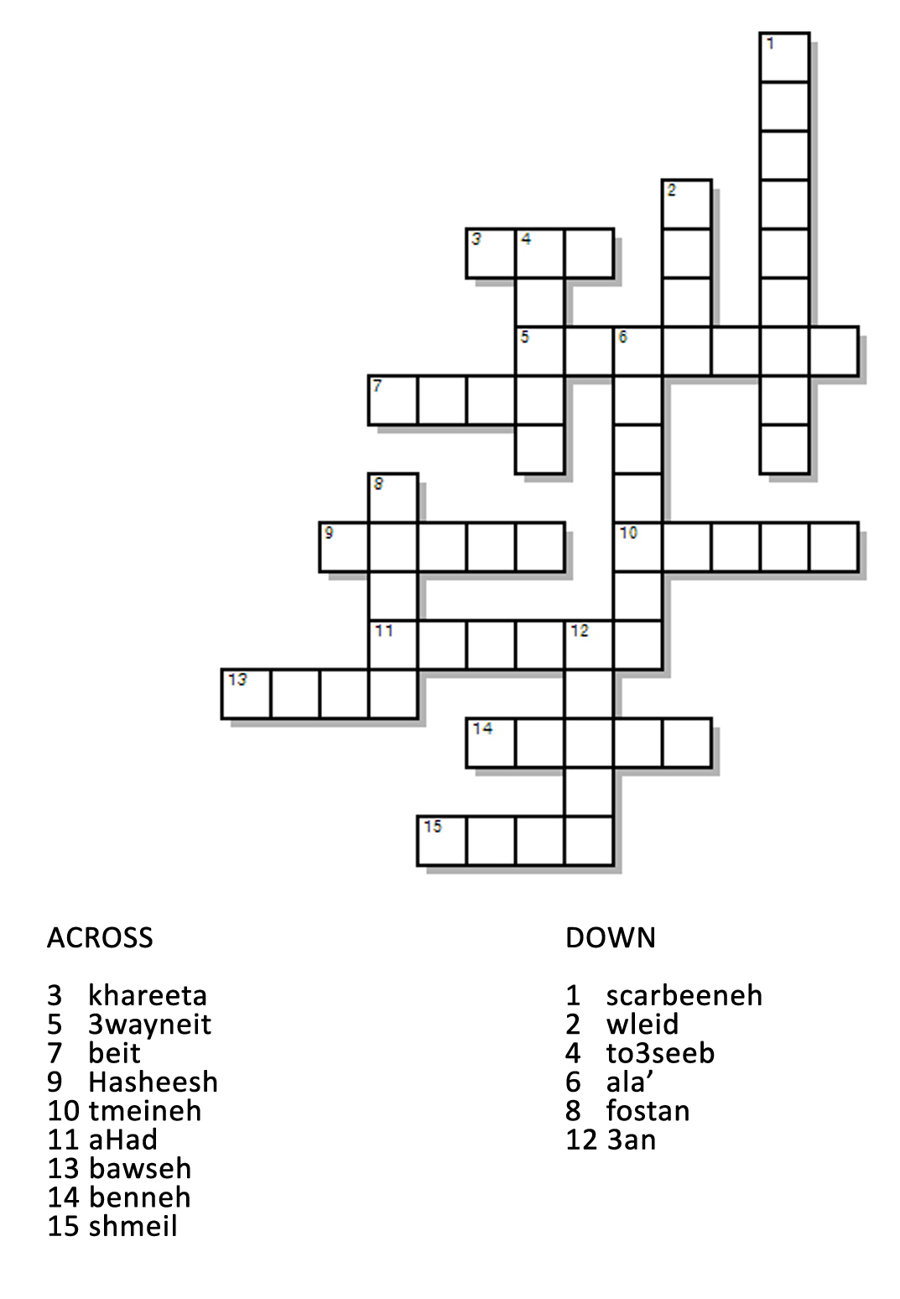

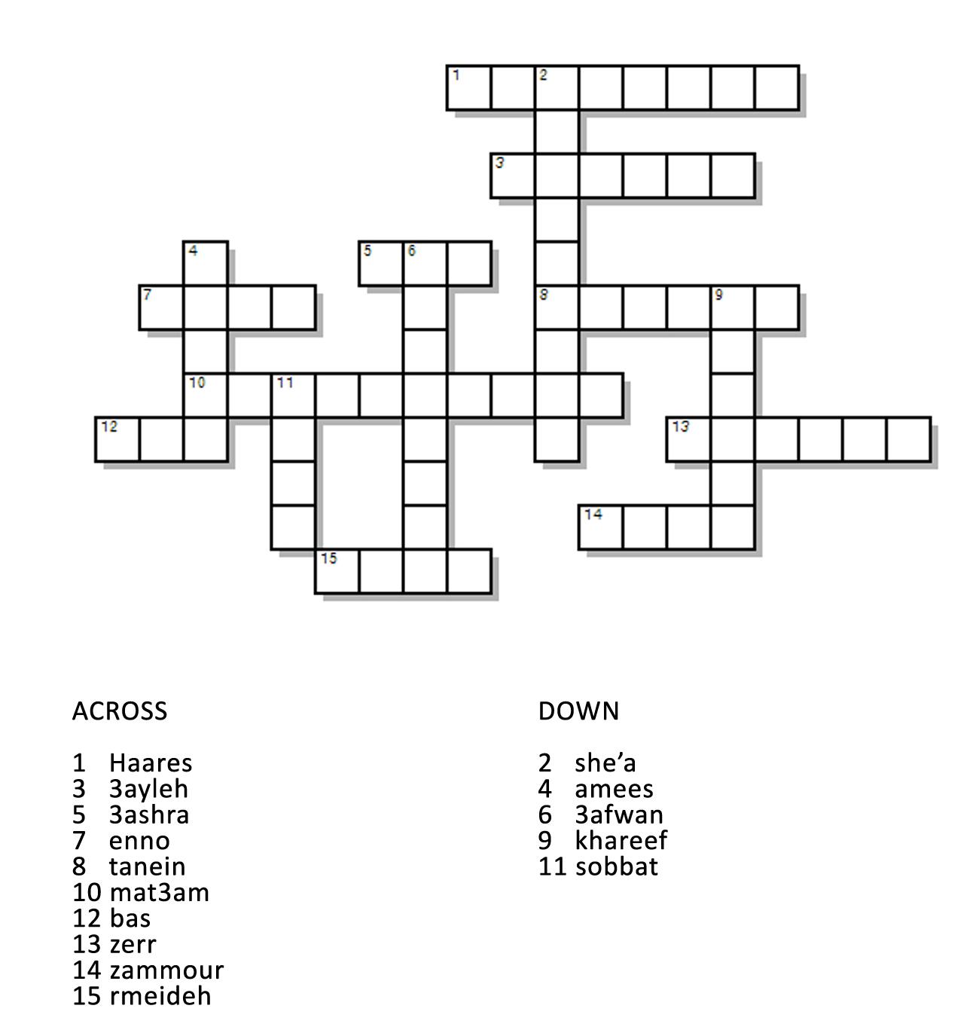

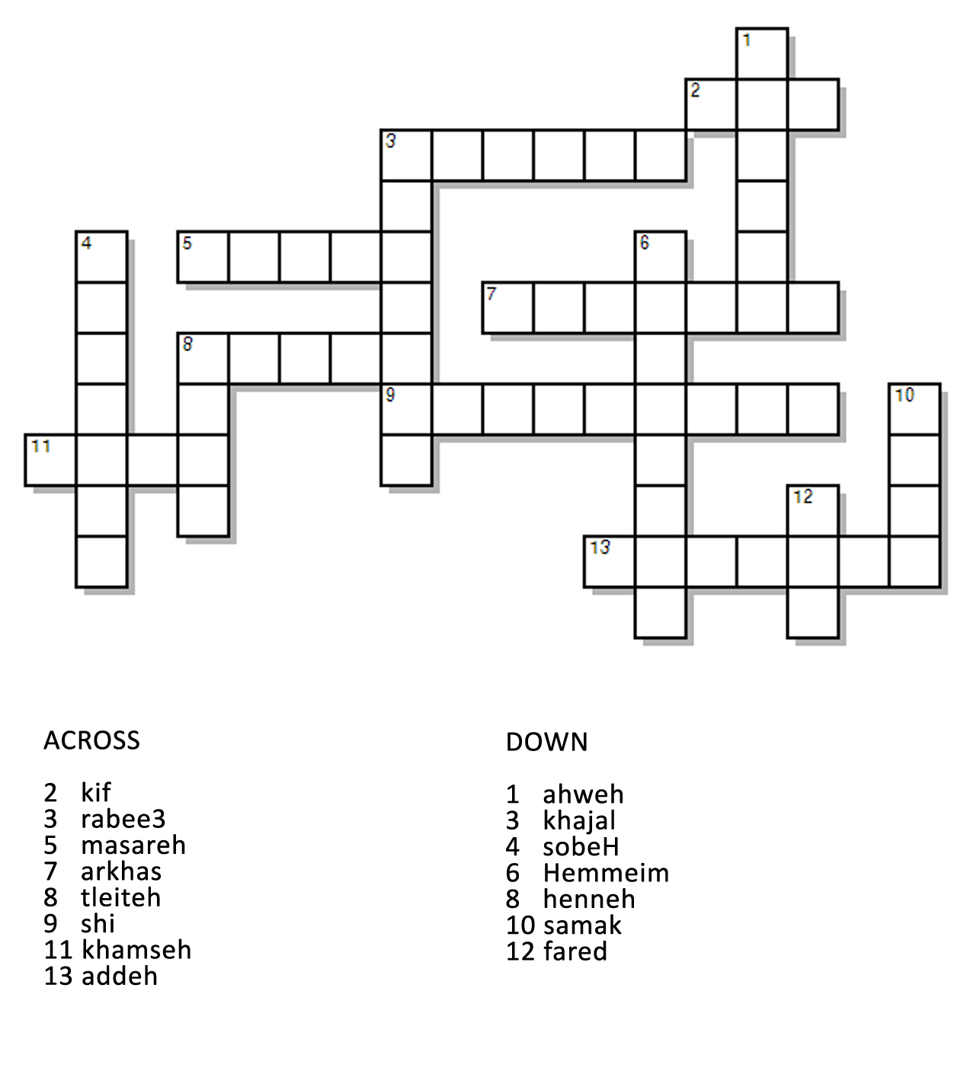

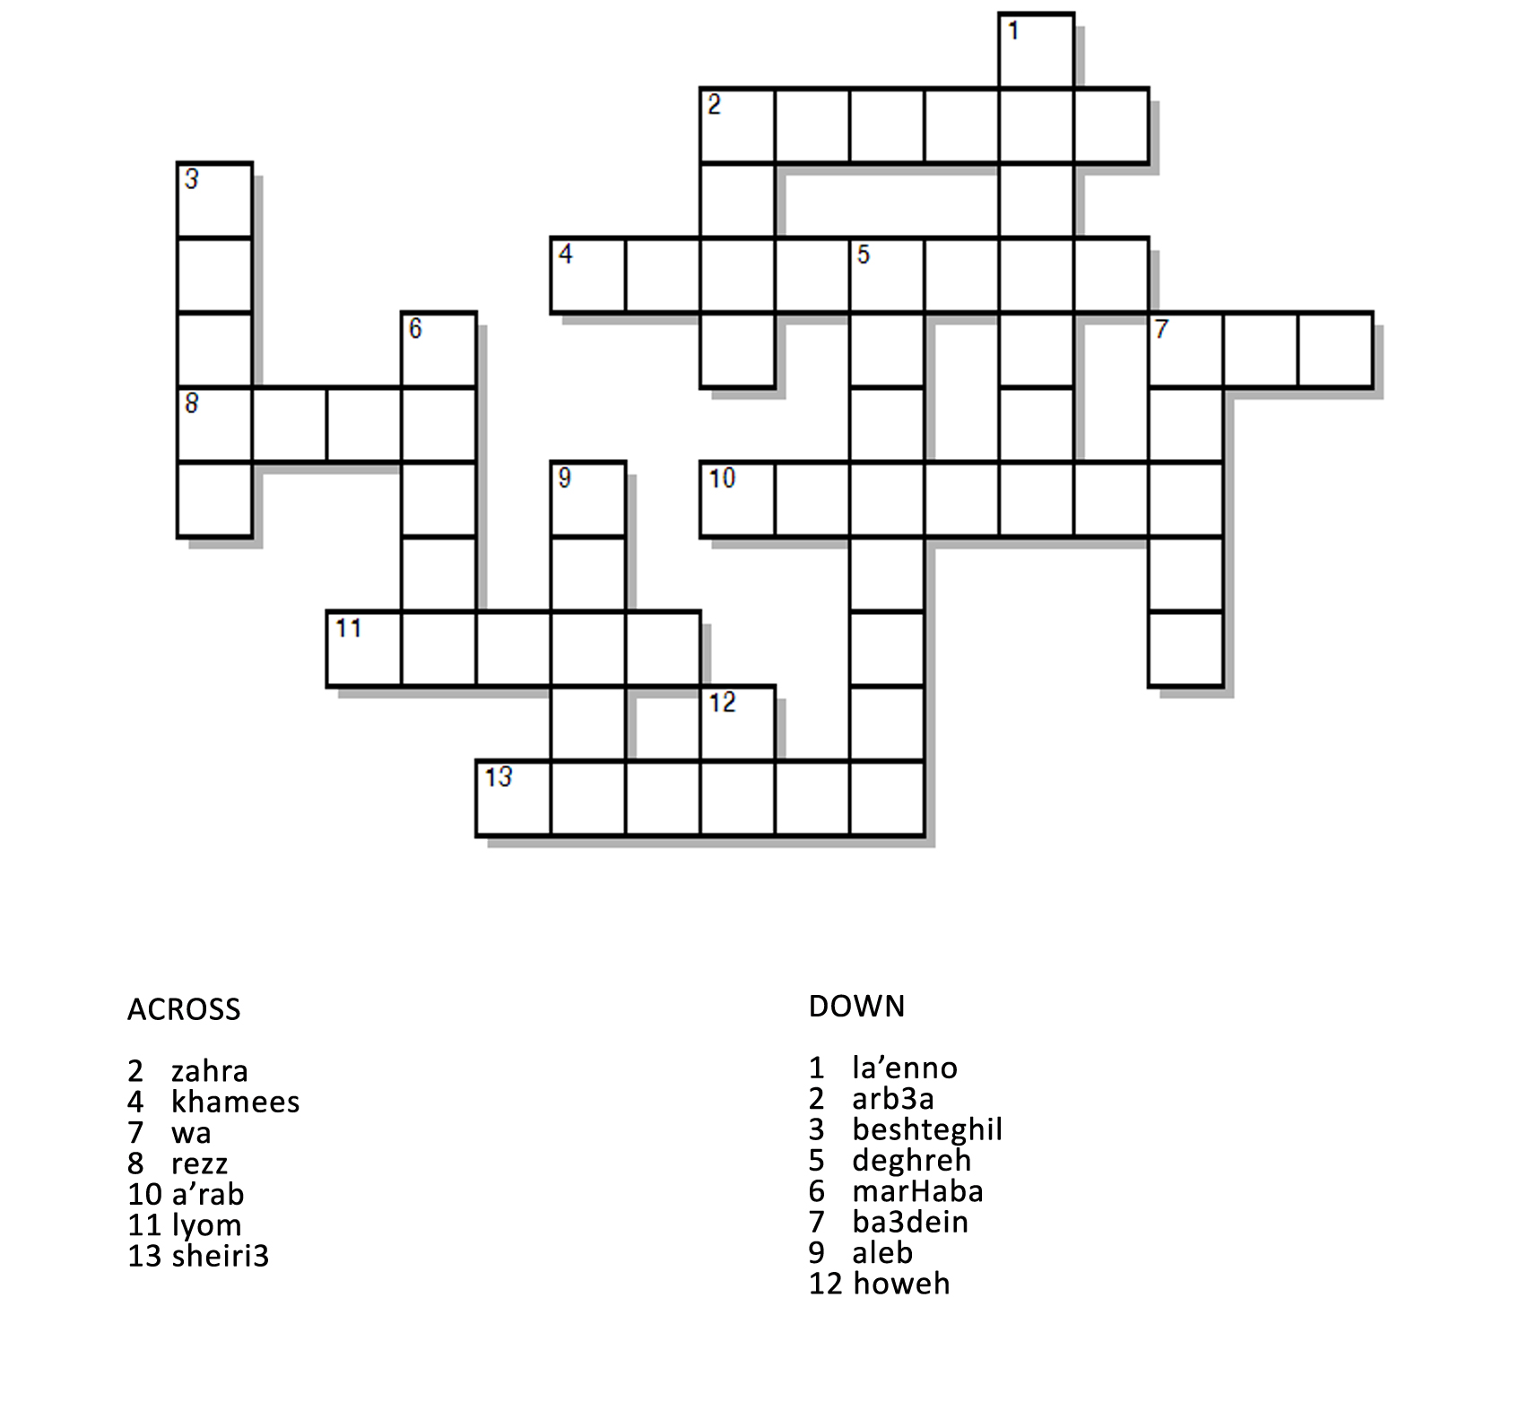

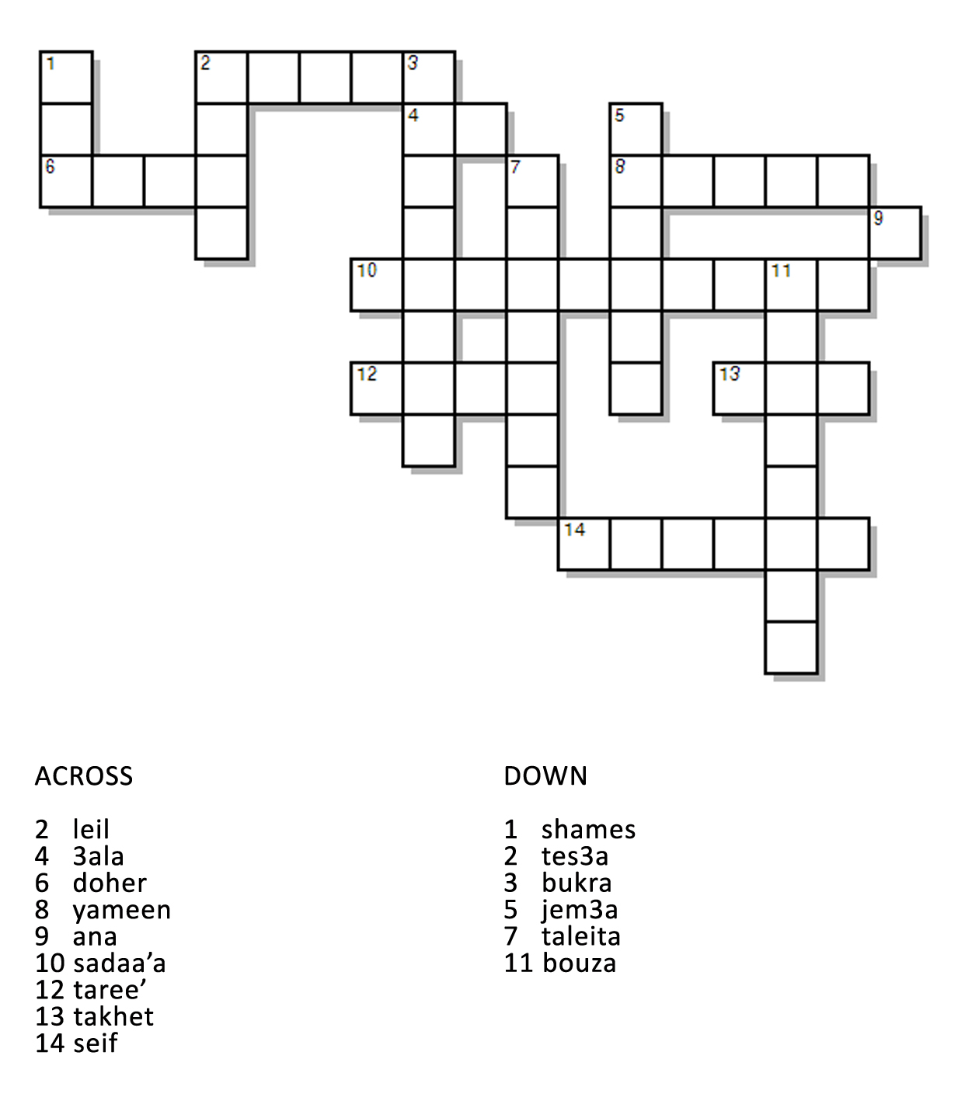

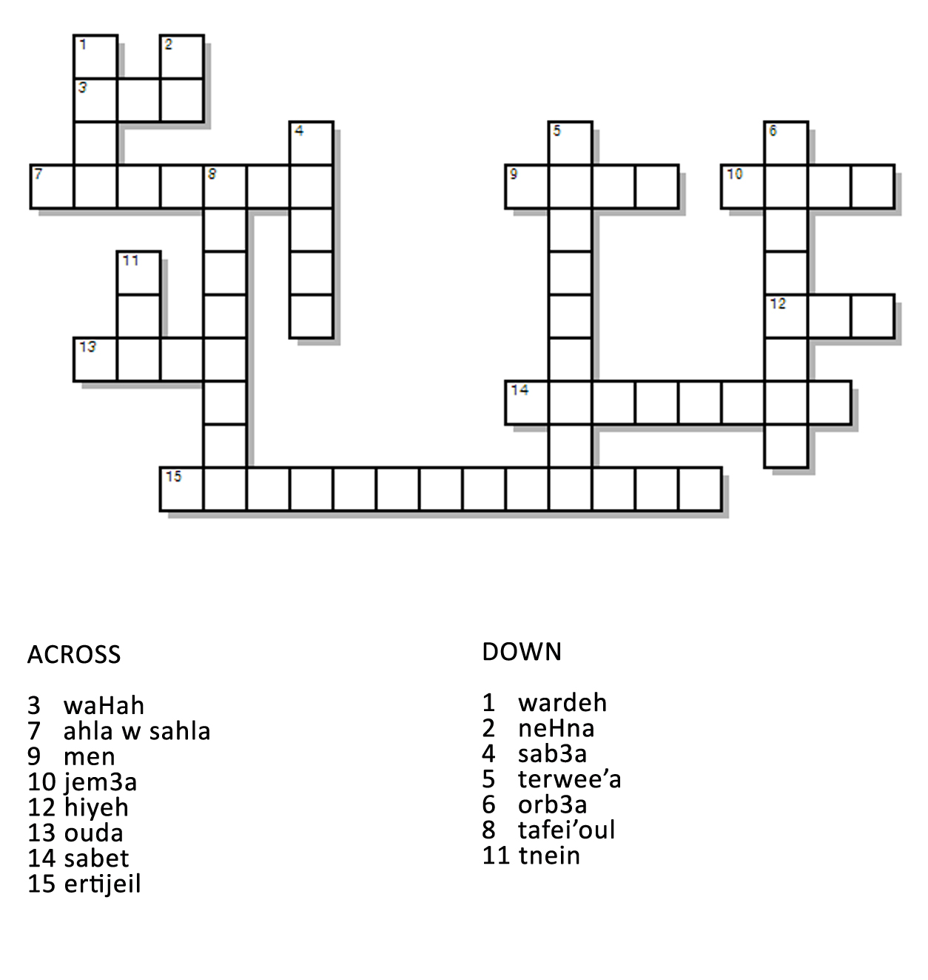

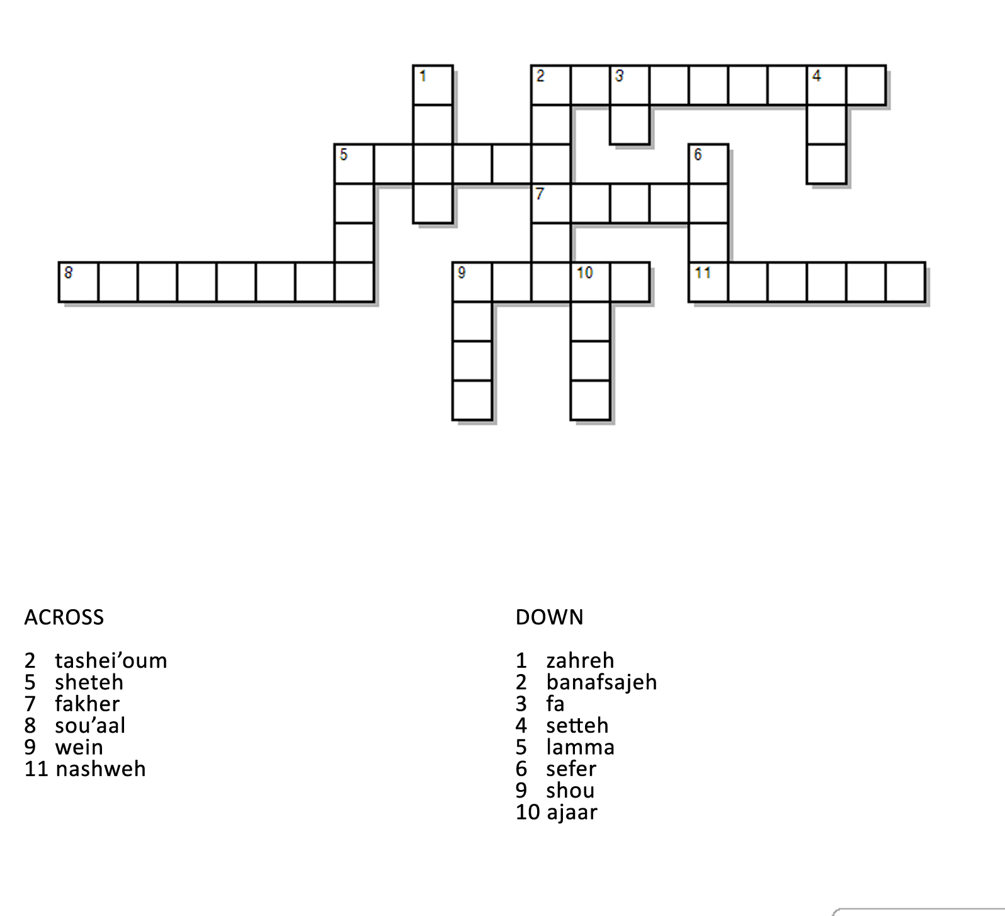

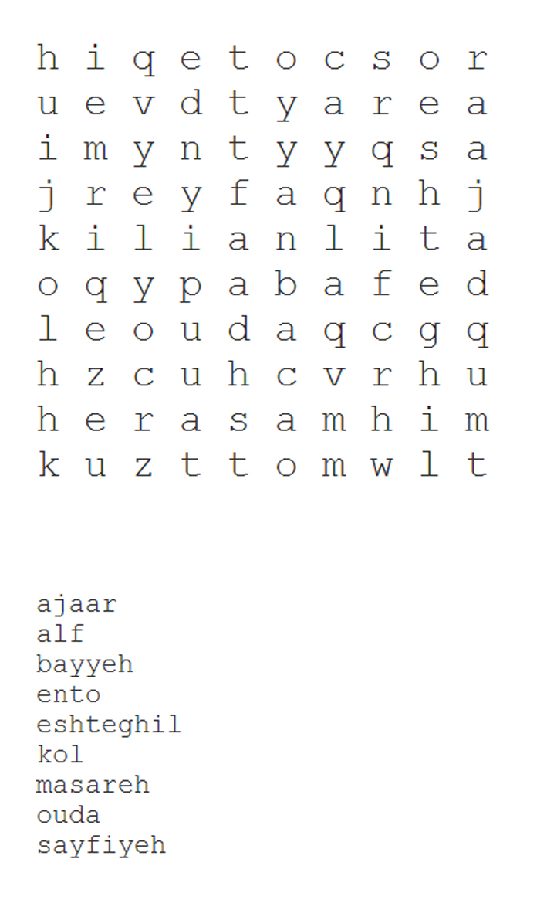

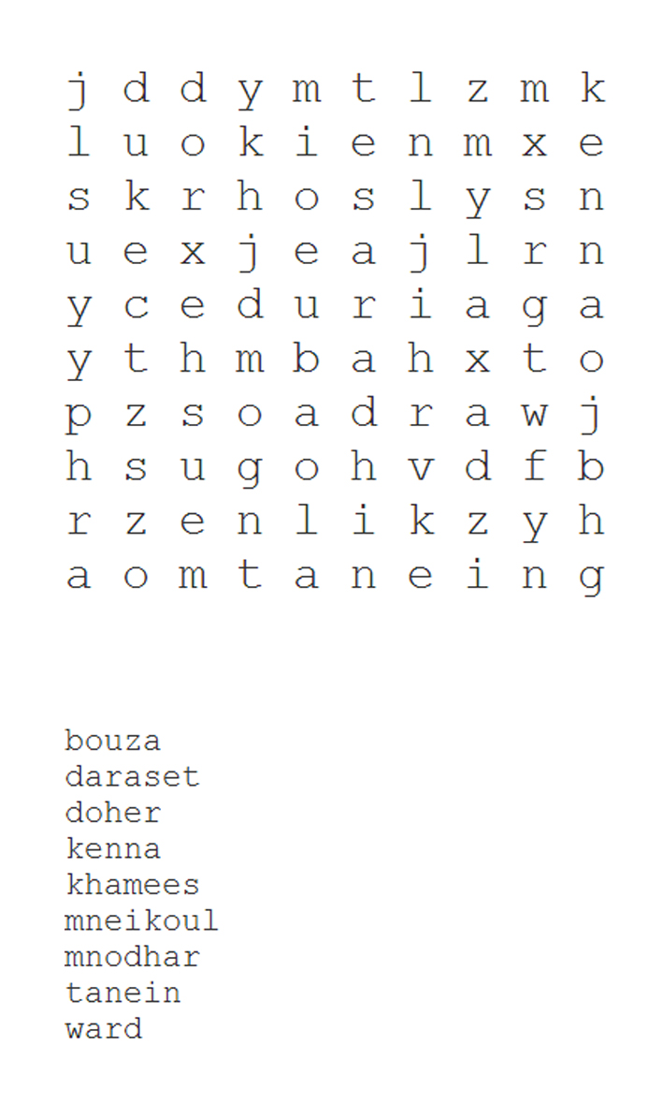

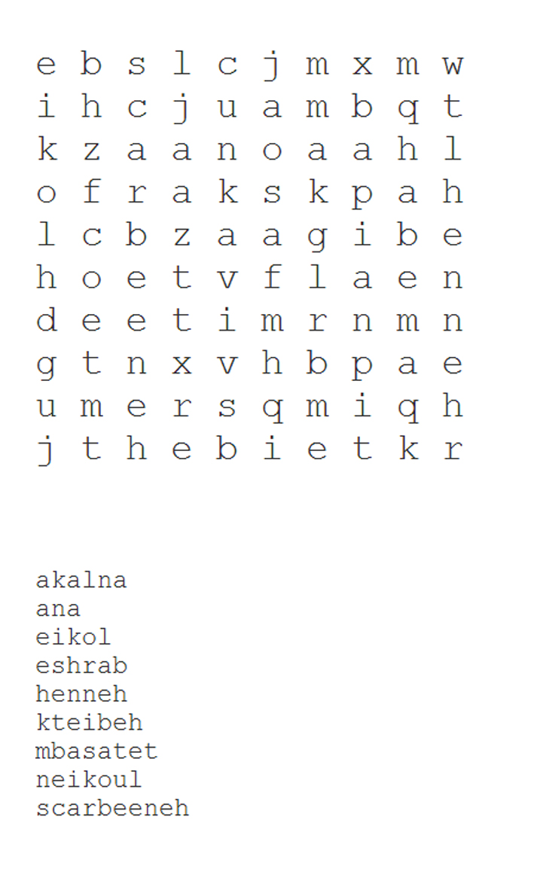

Fill in the Blanks:

neHna halla' b _____ el rabee3, fi shames bas _____ kteer shob, w fi wleid ____ tel3ab barra.

marHaba, ______ eHjouz ouda zgheereh ___ takhet waHad, addeh lezim edfa3 iza ______ yeha la jem3a?

marHaba, baddeh rouH ___ Ashrafieh. ayya bus _________?

bl seif mn _____ 3al baHer. lezim trouH 3al baHer _____ ma tokhlas l sayfiyeh la’enno hala’ neHna b ayloul wel ta’es ____ b seer sa’3a.

lyom l khamees, ____ 3am beshrab ahweh, w ba3dein, _____ 3al neideh

If you would like to download the solutions for the exercises as well as a PDF version of the puzzles for easier printing, please click here.

Conclusion
If you enjoyed the book, I would be very glad if you leave an honest review on the Amazon page of the book. The reviews will help me know what works and what doesn’t so I can fix them in this book, as well as in subsequent volumes.
To leave a review, please click here to go to the Amazon page, scroll down to the end of the reviews, and click on “Write a customer review”.
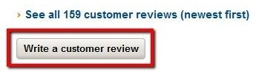
This is the book’s Amazon page:
Thank you for reading my book, I hope you found it to be helpful. In case you have any questions about the Lebanese Dialect, fell free to post it on either my Facebook page, or as a comment on my videos:
Facebook page:
Learn Lebanese Arabic
http://bit.ly/LearnLebaneseArabicFB
Youtube channel:
hiibanajem
http://bit.ly/hiibanajem1
And finally, if you would like to be notified of new videos, lessons and books please enter your email address here: http://bit.ly/FBolVIDoptin

